COURSEWORK SUBMISSION FORM
STUDENT USE |  | STAFF USE
Module Name | Introduction to Information and Web Technologies | First Marker’s  (acts as signature)
Module Code | 3BUIS001C | Second Marker’s  (acts as signature)
Lecturer Name | Shirin Primkulova | Agreed Mark
UoW Student IDs |  | For Registrar’s office use only (hard copy submission)
WIUT Student IDs | 00010023
Deadline date | 2nd of April 2020, 17:00
Assignment Type | Individual

SUBMISSION INSTRUCTIONS

COURSEWORKS must be submitted in both HARD COPY (to the Registrar’s Office) and ELECTRONIC unless instructed otherwise.
For hardcopy submission instructions refer to: http://intranet.wiut.uz/Shared%20Documents/Forms/AllItems.aspx - Coursework hard copy submission instructions.doc
For online submission instructions refer to: http://intranet.wiut.uz/Shared%20Documents/Forms/AllItems.aspx - Coursework online submission instructions.doc

MARKERS FEEDBACK (Continued on the next page)

Table of Contents
Selected website overview 3
Good practices 3
First good practice: 3
Second good Practice: 3
Third good practice: 4
Problems with design/usability + recommendations 5
First problem: 5
Second problem: 6
Third problem: 7
Website development 7
Visual design 7
Code clarification 8
Conclusion 9
References 10

Word count: 1034

Selected Website Overview

From the chosen website, I’ll analyze the good and bad practices of the website. I chose Megasoft.uz website because, this website is one of the most content downloaded websites in Uzbekistan. The address of this website is https://megasoft.uz. Megasoft is a part of Jet Net Uz Project (Company) which previously was named as TPS Internet Provider Company. The Megasoft is website where user can find and download the latest updated software for Windows platform. With the help of the Megasoft service in Uzbekistan you can download software and apps for windows at high speed. With search function, you’re able to find any app you want. The target audience of this website is users of windows operation system who want to get the latest apps. Regarding the content of the Megasoft there are different type of applications inside of the categories such as System, Drivers, Internet, Development, Text, Unix-systems, Security, Media, Graphics and others (Megasoft, 2020).
Good Practices

First good practice:

The first and foremost good practice is the fully responsive website which means that Megasoft.uz is compatible on different devices. According to the HUB (2020) where states that mobile compatibility is one of the most important practices of the web development because of the usage website more on smartphones rather than in PC.

Second good Practice:
The next and very important good practice of the Megasoft is the search engine. Every website should have the search engine and it should be optimized to the content of the website. It is clearly shown that the search engine of the Megasoft is very powerful due to the fact that it’s blazing fast thanks for tas-ix hosting and good server side.
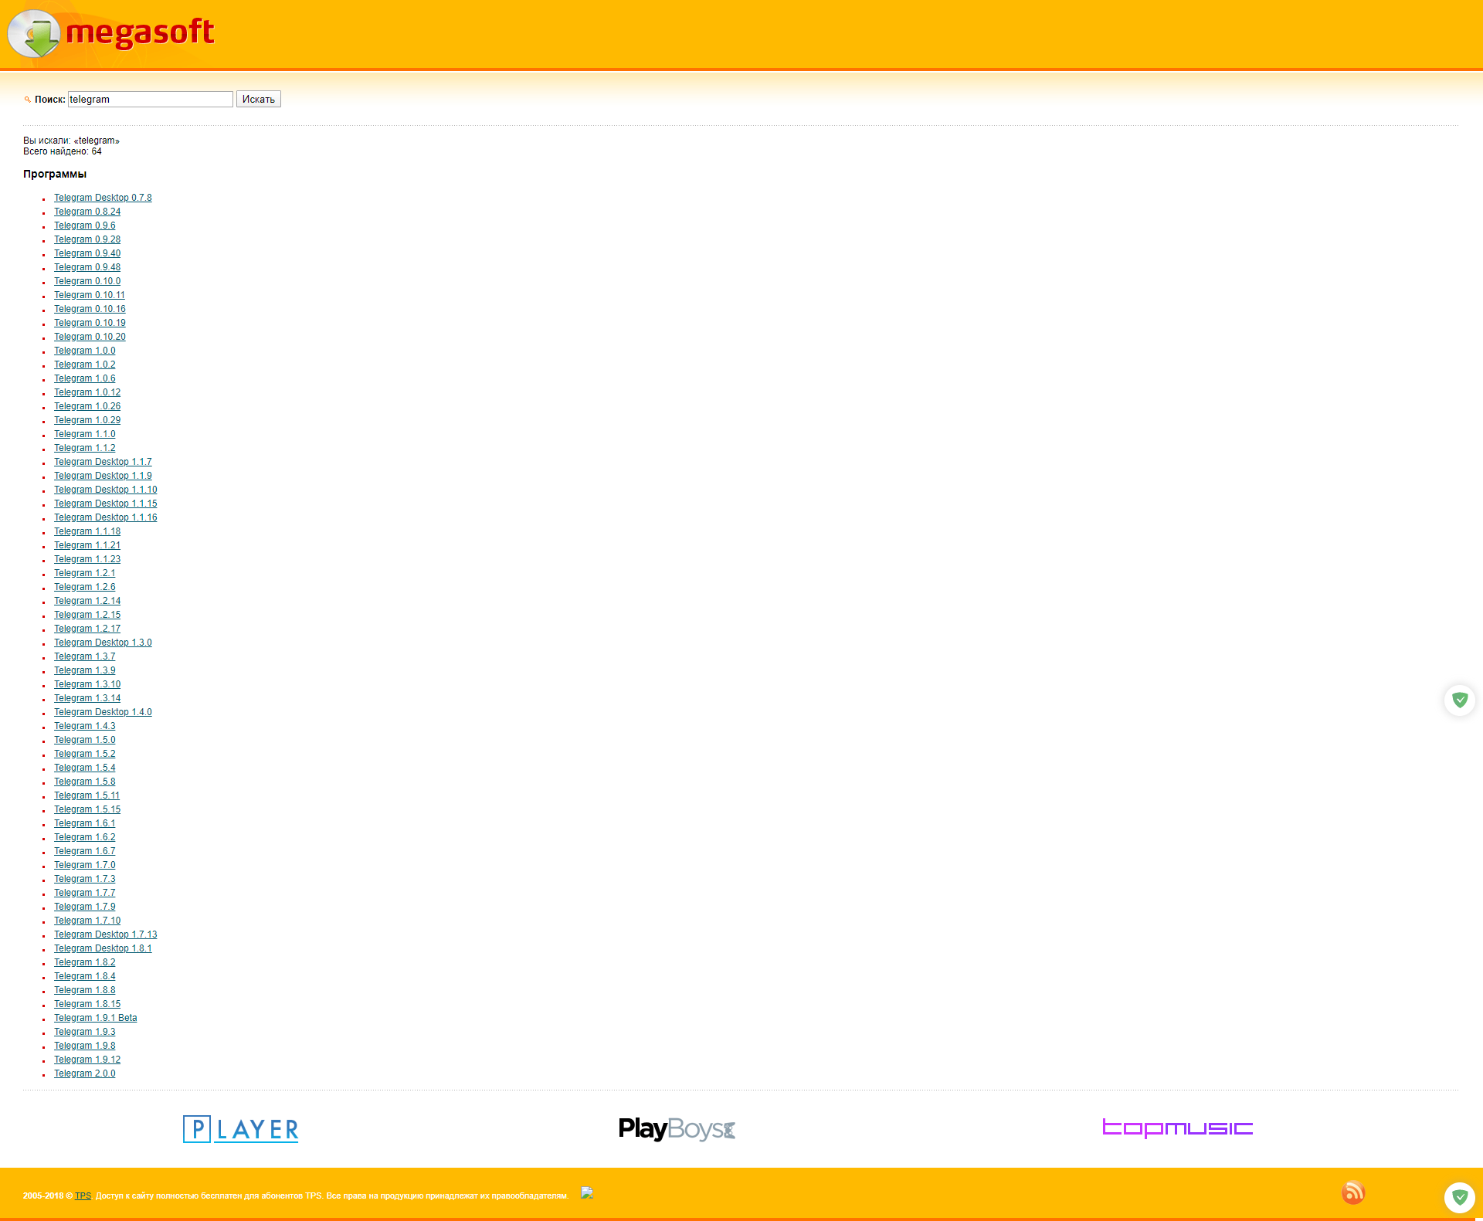

Third good practice:
The last good practice of the Megasoft is that it has clear website content especially clear heading, pagination. According to the TinkerEdge (2020), the website content is on the top of 10 checklist of the good practices of the website. The content of the Megasoft is perfect due to the all features and the optimization, the speed of the website is very fast and all necessary features for the user are implemented here. The overall screenshot of the website illustrates that the content of the website is clear.
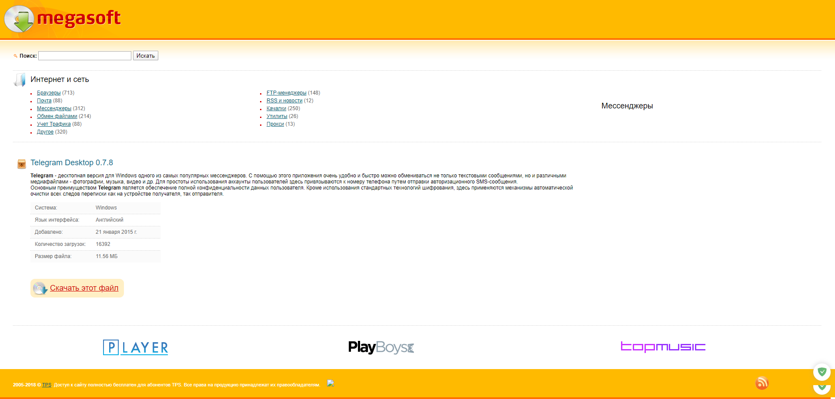

Problems with Design/Usability + Recommendations

First problem:

The first and foremost problem of the Megasoft is old fashioned. When the user enters to the Megasoft.uz in order to download app, some of visitors might think that the content of this website could be old too. According to the Immerge (2019) who stated that old fashioned websites can affect to the count of visitors and length of visit. There is only one recommendation to the company is to update and make the website more beautiful, add some new design.
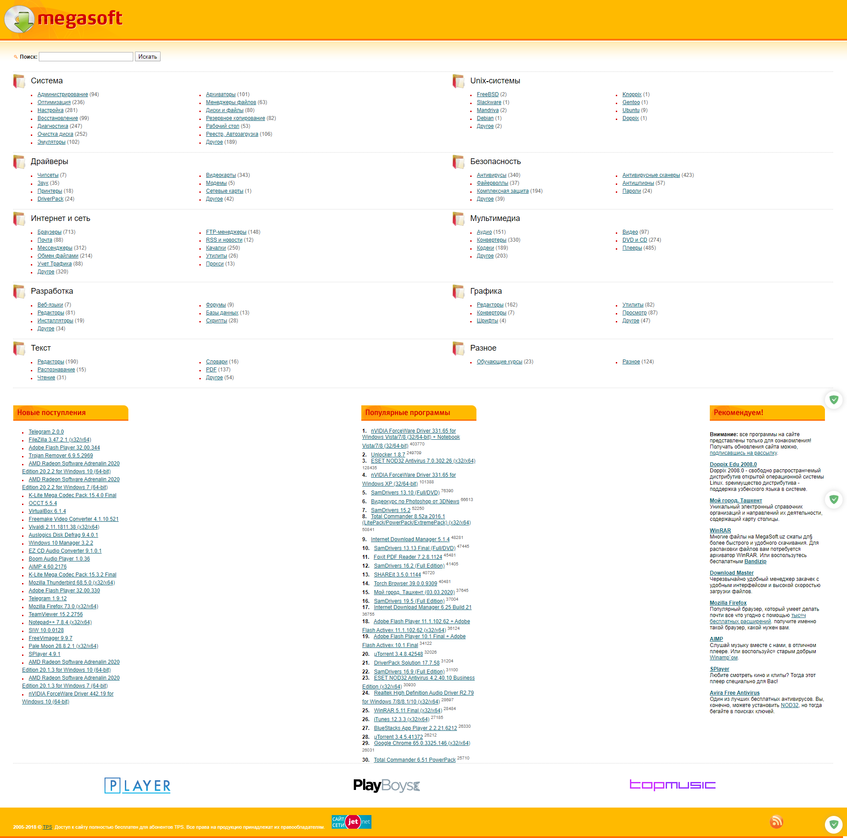

Second problem:

Secondly, there are only one language on Megasoft and it is considered to be bad usability of the website. According to the TinkerEdge (2020), availability of the multi-language in website is very good practice, but if there is not, the is not good usability for the clients. For example, what if the user’s native language is the English and the client want to buy a car, it could not find the graphics category due to the language misunderstanding. There is only one recommendation to the Megasoft is to make English language also.

Third problem:

The last problem of the Megasoft is that it has no navigation menu on website which can navigate to various pages of the website. As an example navigation to the main menu of the website or link to account management. According to TinkerEdge (2020) the website should have navigation and it should have important navigations to the significant pages. The only recommendation to the webmaster is to add navigation bar with major links.

Internet Tarif Description

To calculate the price for per user, I started picking up a number of provider and I took UzTelecom, Sarkor Telecom and ISTV. After that, I picked up internet tariffs as possible as same with speed.
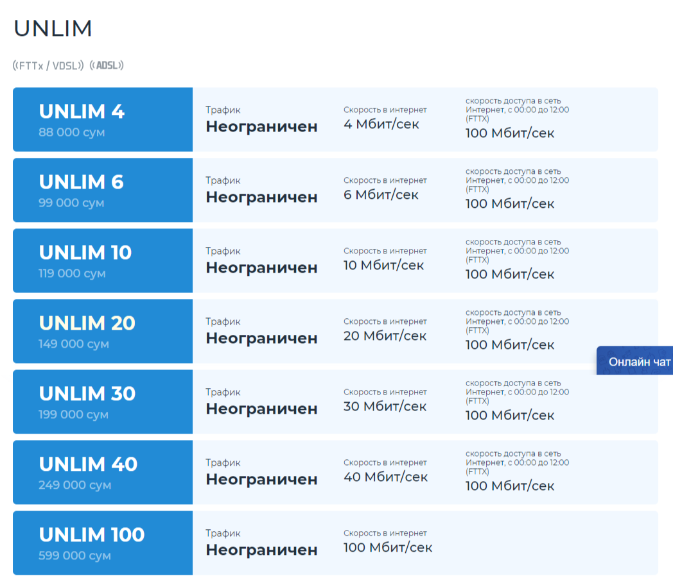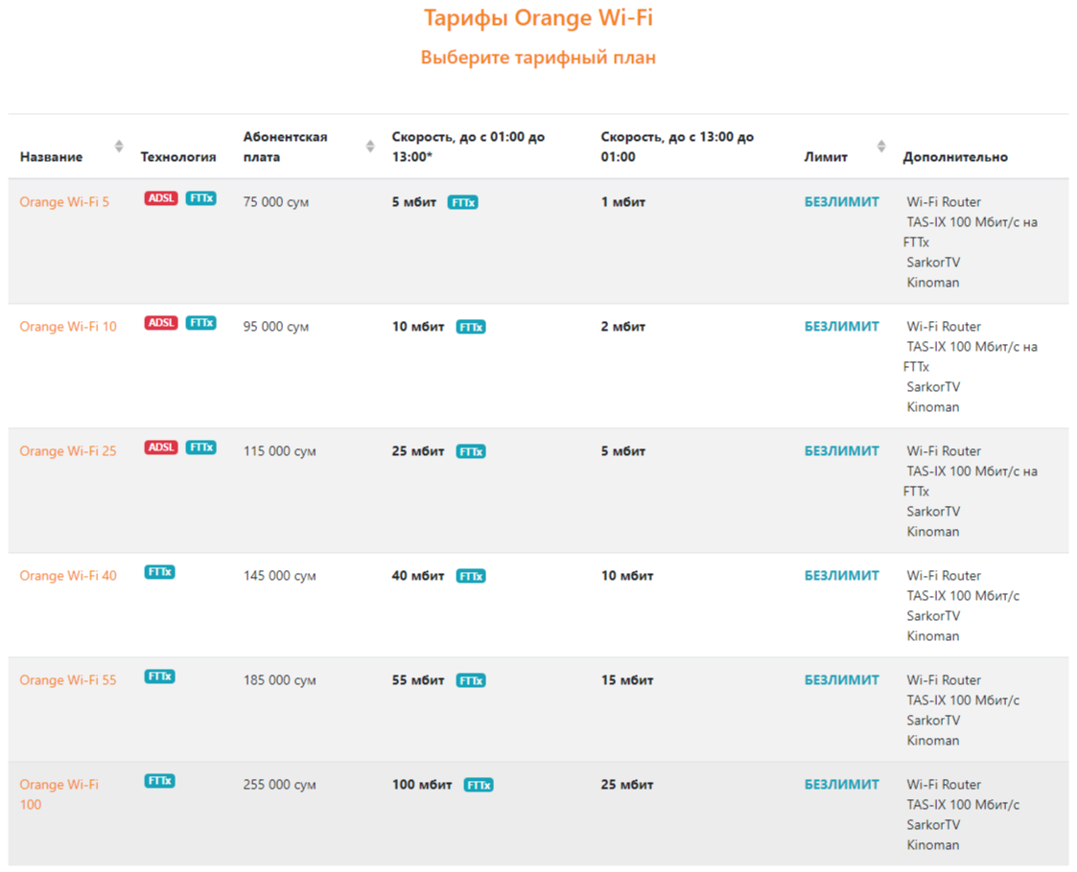
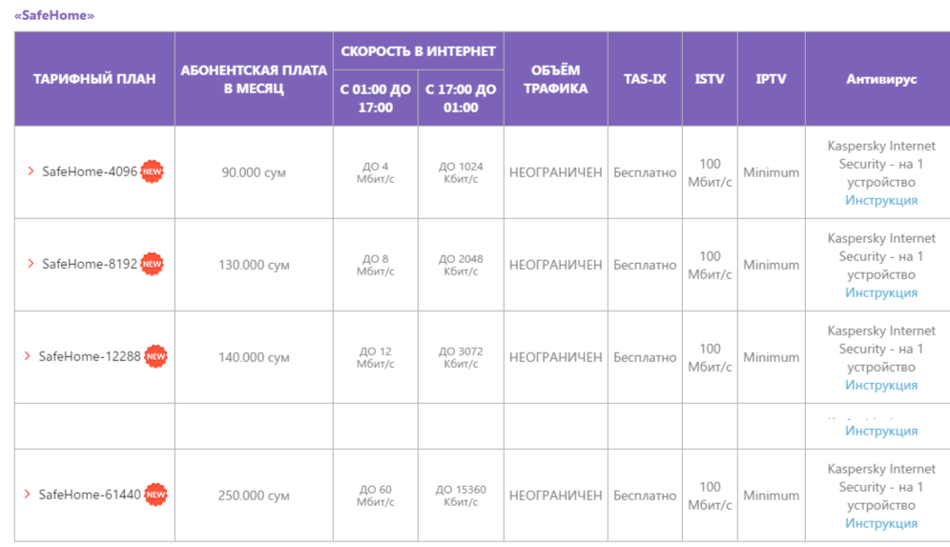

Then, assumed all information about internet tariffs, entered all information to excel file and started to calculate the prices. At the first stage, I took expenses and calculated over this formula: “Connection Expense / Internet User”. At the second stage, I calculated the price of per user with this given formula below: “Price of tariff / Count of Internet Users”. Finally, I got this result at the end.

Website Development

For the coursework project I chose SoftClub.uz which company’s official release will be available soon. Over my friends, I found out that this company is going to publish their own serving website that will server as educational IT course selling website. I decided to challenge and make my own version of website. I used JetBrains IDE like WebStorm to build my website. WebStorm is a professional coding environment editor that helps you to code like professional.

Visual Design

I contacted with my friends and asked for the style of future website. They told me that it will be gradient colors of blue and violet. I just predicted the look and feeling of the website and tried to make my own version as you can see below:
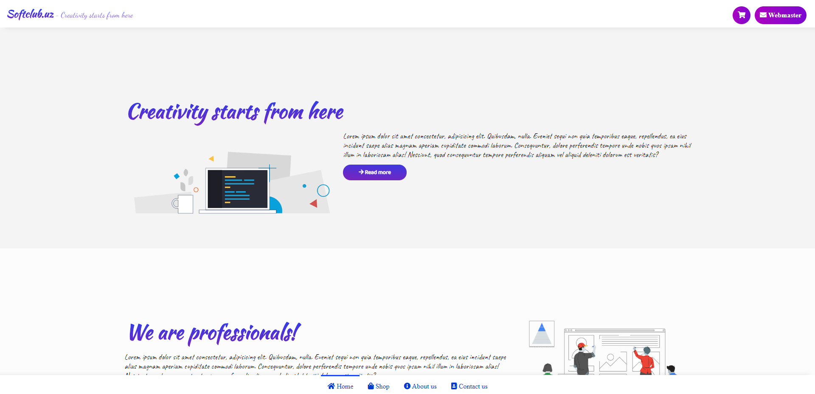

Code Clarification

For the development of website, I used Font Awesome (library of icons) and Google Fonts. As regards to the structure of website, I built my website with only html and css. I tried to do not use javascript in order to optimize and make my website load & work faster. Instead of JS I used the own css engine for animation and loading effect, etc.
On the line 8 of all html files you can see that I connected Google Fonts as Baloo, Caveat, Dancing Script, Gotu, Kaushan Script, Lobster, Lobster Two, Marck Script, Oleo Script Swash Caps.
<link href="https://fonts.googleapis.com/css?family=Baloo+2|Caveat|Dancing+Script|Gotu|Kaushan+Script|Lobster|Lobster+Two|Marck+Script|Oleo+Script+Swash+Caps&display=swap" rel="stylesheet">

As regards to Font Awesome (library of icons) I connected this library on 10th line of all html files and looks like:
<script src="https://kit.fontawesome.com/ca1e82e502.js" crossorigin="anonymous"></script>

This script served me as icon manager for my menus and tabs
For navigation I used this style of navigation:
<div class="bottom-navigation">
<ul>
<a href="index.html"><li class="active"><i class="fas fa-home"></i> Home</li></a>
<a href="shop.html"><li><i class="fas fa-shopping-bag"></i> Shop</li></a>
<a href="about.html"><li><i class="fas fa-info-circle"></i> About us</li></a>
<a href="contact.html"><li><i class="fas fa-address-book"></i> Contact us</li></a>
</ul>
</div>

As it can be seen from the picture below, I opened a div content, put a ul and anchors there. Before the text of menus, I included icon for clarity.
Conclusion

In conclusion, thanks for the IIWT course, I practiced and sharpened my skills on web development sphere. I appreciate the work and effort of our staffs and the module leader did us. I hope that I’ll be the participant of IT modules from upcoming semesters.
References

Megasoft (2020). Megasoft.uz. Available from http://megasoft.uz [Accessed 1 April 2020].
Google Images (2020). Google.co.uz. Available from https://www.google.co.uz/imghp?hl=uz&tab=wi [Accessed 15 January 2020].
TinkerEdge. (2020). Website checklist with more than 60 best practices. Available from https://www.tinkeredge.com/website-checklist.html [Accessed 1 April 2020].
Immerge. (2019). THE DISADVANTAGES OF HAVING AN OLD SITE. Available from https://www.immergetech.com/blog/detail/disadvantages-of-having-an-old-site [Accessed 1 April 2020].
Google Fonts (2020). Fonts for the website. Available from https://fonts.google.com/ [Accessed 1 April 2020].
Font Awesome (2020). Icons for the website. Available from https://fontawesome.com/ [Accessed 1 April 2020].

